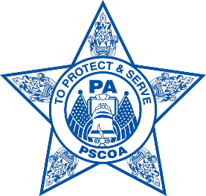
PENNSYLVANIA STATE CORRECTIONS OFFICERS ASSOCIATION
2421 N. Front St.
Harrisburg, PA 17110

PSCOA ISSUES STATEMENT ON WOLF ADMINISTRATION LAW ENFORCEMENT REFORMS

Harrisburg, Pa. (June 5, 2020) – Pennsylvania State Corrections Officers Association (PSCOA) President Larry Blackwell today issued the following statement on Gov. Tom Wolf’s proposed law enforcement reforms:

“The members of the Pennsylvania State Corrections Officers Association courageously go to work each day to keep the peace in some of the most dangerous facilities anywhere — and they perform their jobs with integrity. Our members are already subject to a strict disciplinary system that holds everyone accountable for their behavior. While the Governor moves forward in his attempts at policing reforms, we must remember the outstanding law enforcement officers throughout the commonwealth who risk their lives each day to keep Pennsylvania’s families safe and, equally important, the victims of crime.

“Gov. Wolf’s own Department of Corrections found that last year, 1,768 violent crimes were committed by parolees. More than 100 parolees committed felonies, including murder. These statistics are not disputed. Just last fall, stories in the media revealed in a span of two months, five parolees committed six murders, including two children under the age 8 and an off duty Pittsburgh police officer. We cannot forget about these victims and their families.

Here are some links to those stories:

https://www.pennlive.com/news/2019/07/recapping-the-six-recent-parolee-homicides-that-sparked-investigations.html

https://pittsburgh.cbslocal.com/2019/07/22/christian-bey-charged-with-criminal-homicide-in-connection-to-officer-calvin-halls-fatal-shooting/

https://www.baltimoresun.com/news/crime/bs-md-cr-parolees-charged-homicides-20190722-20190723-mccobuzi45axjiya77ugoaxdpq-story.html

# # #

